## Exercise 1: Dice

Use object-oriented programming method to create a C# program with the following requirements:

* Users enter a number of sides of Dice
* The program will generate a random number from 1 to the number of sides

What **classes** should we create?

* Class: Dice
  + Fields: slides
  + Methods: roll (generate a random number from 1 to sides)
* A class to run the program

### Exercise 2: Create classes with the following components

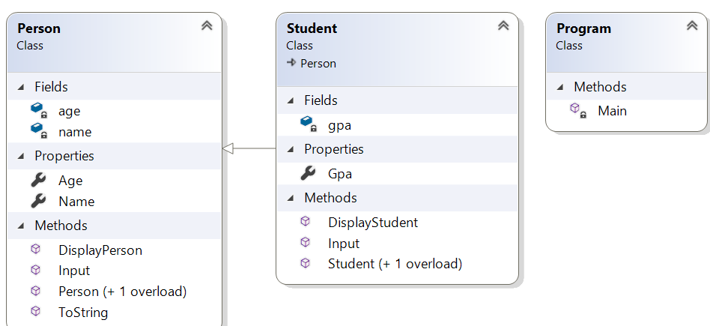

## Exercise 3

Define a class **Song**, which holds the following information about songs: **Type List**, **Name** and **Time**.

On the first line you will receive the **number of songs** **-** **N**.

On the **next N-lines** you will be receiving data in the following format: **"{typeList}_{name}_{time}".**

On the last line you will receive **Type List** / **"all".** Print only the **Names of the songs** which are from that **Type List** / **All songs**.

### Examples

| **Input** | **Output** |
| --- | --- |
| 3  favourite_DownTown_3:14  favourite_Kiss_4:16  favourite_Smooth Criminal_4:01  favourite | DownTown  Kiss  Smooth Criminal |
| 4  favourite_DownTown_3:14  listenLater_Andalouse_3:24  favourite_In To The Night_3:58  favourite_Live It Up_3:48  listenLater | Andalouse |
| 2  like_Replay_3:15  ban_Photoshop_3:48  all | Replay  Photoshop |

## Exercise 4: Make a Fraction class in C#

Create a class called Fraction to perform arithmetic operations with fractional numbers.

Write a program to test this class:

Use integer values to represent the attributes of the class – the numerator and the denominator.

Create public methods to perform the following:

* Input two fractions. The result is normalized.
* Add two fractions. The result is normalized.
* Subtract two fractions. The result is normalized.
* Multiply two fractions. The result is normalized.
* Divide two fractions. The result is normalized.
* Display a fraction as follows: (A/B). A is the numerator, B is the denominator
* Display a fraction on the screen as a decimal number.

### Solution of Exercise 3

Define class Song with properties: **Type List**, **Name** and **Time**.

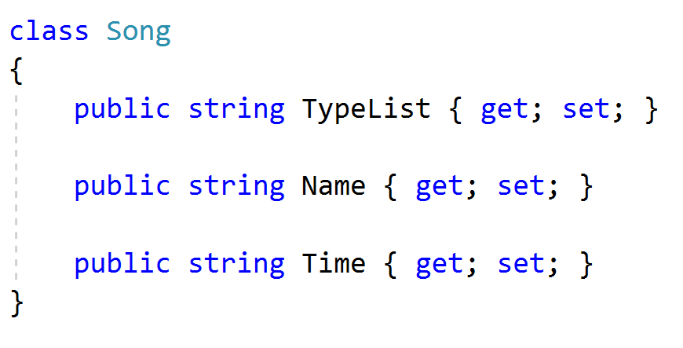

Read the input lines, make collection and store the data.

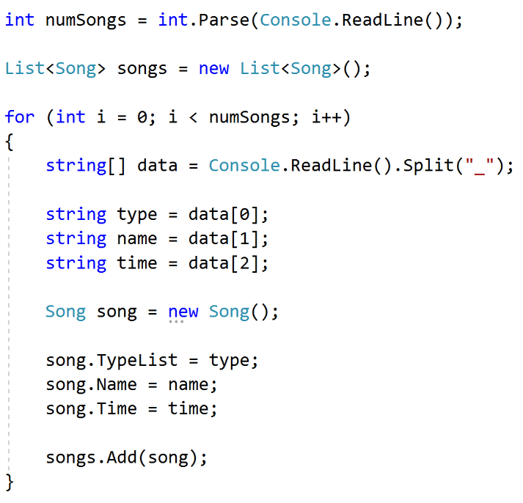

Finally read your last line – **Type List** and **print** the result.

